AMERICAN BAPTIST FOUNDATION SEMINARS
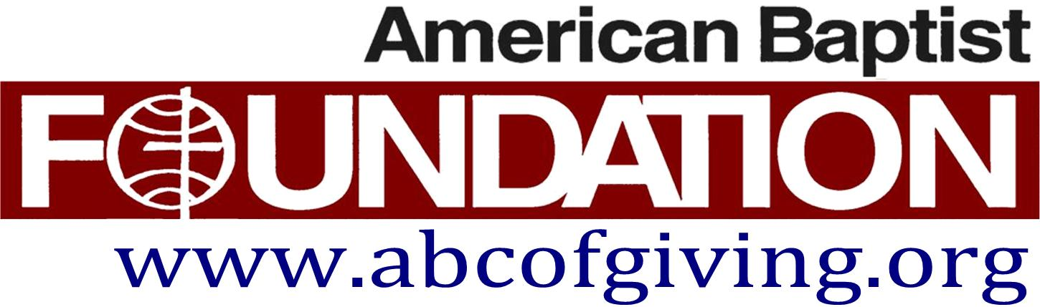
Registration

ENDOWMENT & INVESTMENT SERVICES
STRENGTHENING YOUR FINANICAL FUTURE

Who should attend? Finance Committee / Trustees / Pastors
Please send 2 to 3 people to represent your church.
SATURDAY, MAY 18
□ TIME 9:30 to 11:00 AM WESLEYVILLE BAPTIST CHURCH ERIE, PA 16510
□ TIME 3:00 to 4:30 PM FIRST BAPTIST CHURCH MEADVILLE, PA 16335

REGISTRATION

Please complete the Registration Form and return to: Kris.Lutton@abc-usa.org

CHURCH you are representing:___________________________________________

Representatives Names & Positions: (type on this form, it’s in Word, & return to Kris)
- )

- )

- )

To register for our seminar please complete the Registration Form & return it to Kris Lutton.
So I can prepare appropriately, please E-mail a scanned copy of your 2018 Annual Report & Financials. All documents submitted are kept CONFIDENTIAL.
Would you like an ABF representative to meet with your Trustees? □ Yes □ No

Questions? Contact Kris Lutton: e-mail Kris.lutton@abc-usa.org or 406.581.7016 cell
RSVP Deadline: Tuesday, May 7, 2019

